WinForms Facebook App

The app start with a login button, which followed be a page similar to the old familiar Facebook profile page, but way lamer…

Each profile page is divided to 3 main areas:

* The top panel – Where you'll see the currently viewed user profile & cover photos,

You could open the settings form (currently only having save credentials functionality)

You could click the statistic button and see a great deal of interesting info about yourself!

You can activate the infamous PARTY button and get your app to some groovy places…. And you can always click on your own face to go back to your profile page.

* The left panel – where all of the currently viewed user info is located (sex,age,place of birth and so on…) also showing a preview of the users photo albums and friends (which you could navigate to via clicking on their profile pic)
* The feed panel – where you can browse through your textual & image posts (video and links are still unavailable), write your own textual status, and like or comment to each and every one of the available posts!

1. Class Diagram:

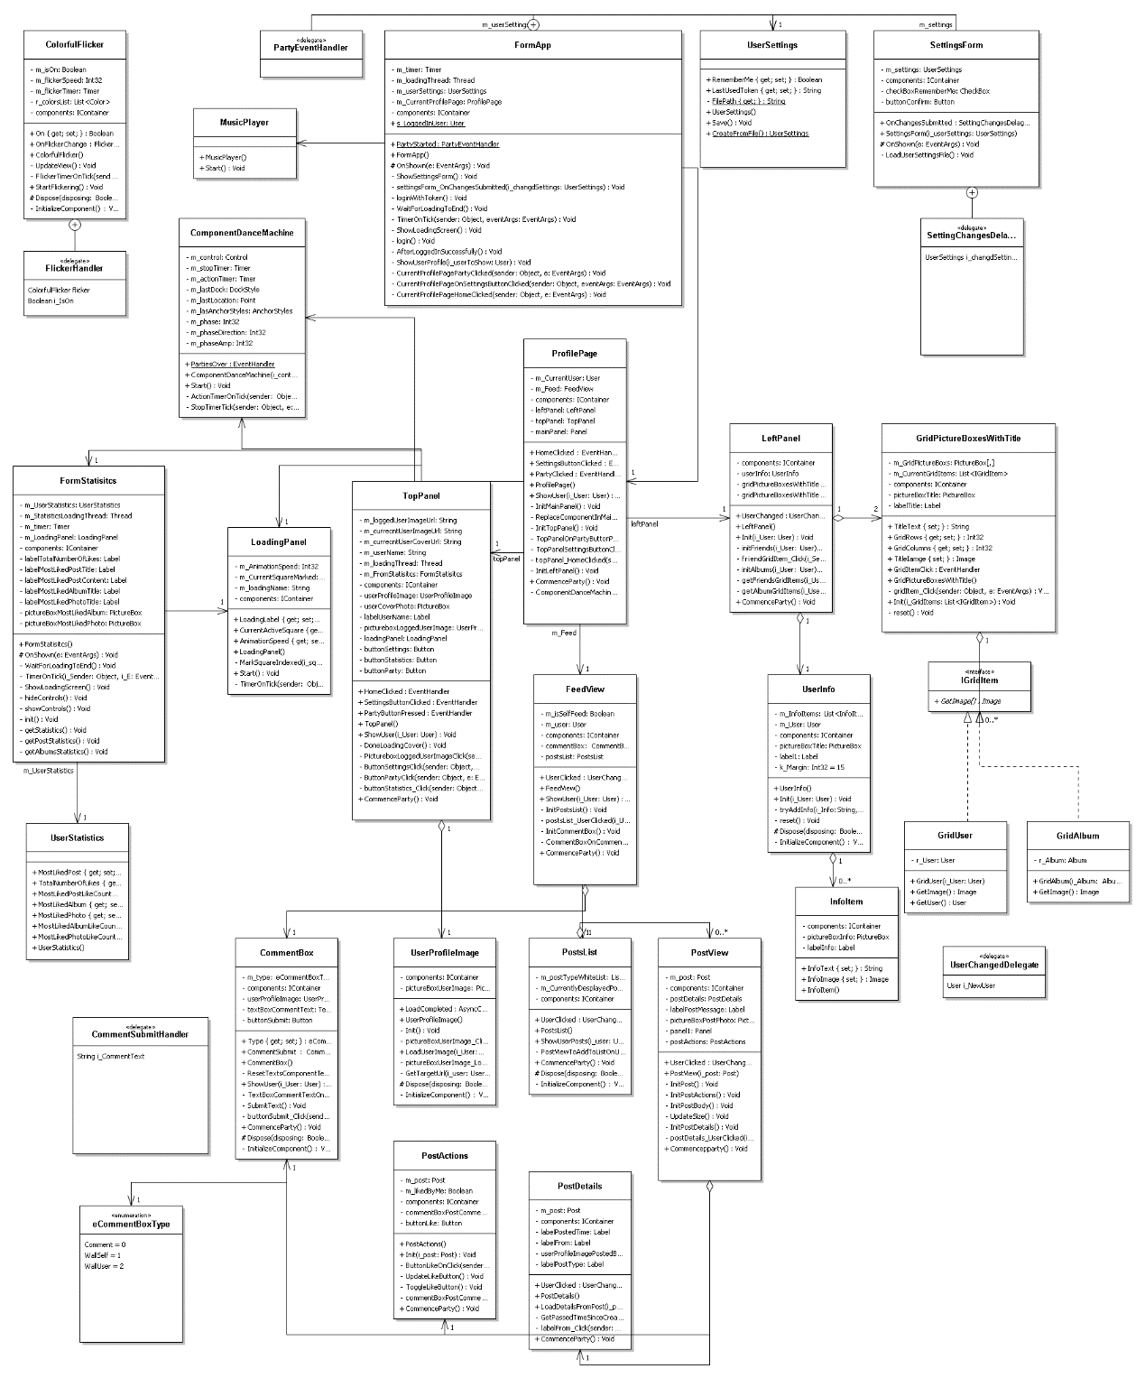

1. Usecase Diagarm:

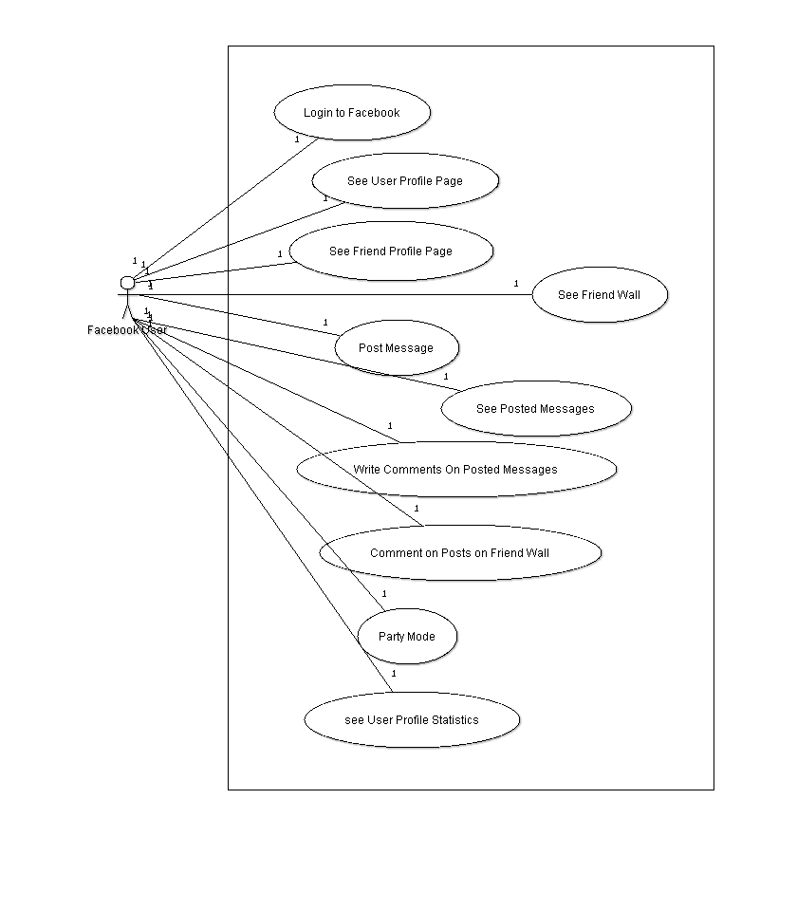

3)A) See User Profile Statistics SequenceDiagram:

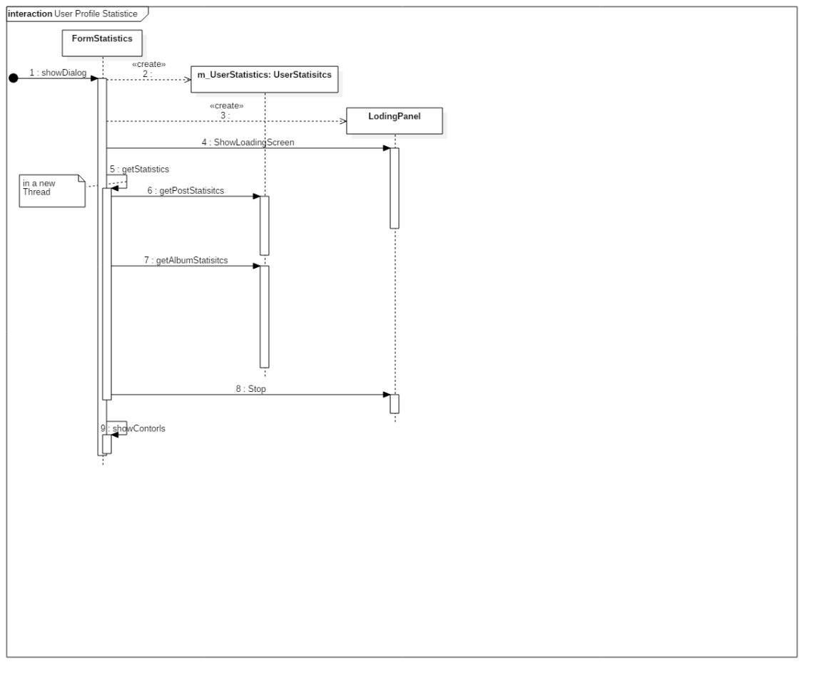

3)b) Activate PARTY MODE ! ! !

